ADE Air Quality – Modeling & Simulation of Indoor Air Quality

*Massachusetts, USA, October 2018  
Jonathan Jacobs*

Introduction

Modeling and simulation of indoor air quality is a critical piece to technical decision making and hypothesis testing. It allows for low-cost, low-time tests to be done in order to inform the direction of physical experimentation and prototyping. *In this assumption test, we explore the feasibility of building an indoor air quality model and its validity as a technical tool.*

In order to conduct this $0.50 assumption test, we identified and adapted an appropriate mathematical model, implemented it in Matlab, and generates a variety of graphs to inform our thinking about infiltration and deposition rates and their effect on indoor air quality.

In conclusion, we were able to build a compelling model. The results of which have contributed significantly to the ongoing conversation about the validity of addressing infiltration rate as a solution to indoor air quality, the model having shown that even dramatic changes in infiltration rate have a modest effect on indoor particulate concentration.

Method

1. *Identifying and adapting a theoretical model*

We began by identifying a theoretical model for indoor air quality from *Textbook name:*

$$V\frac{dC}{dt}=\left(S+C_{a}IV\right)- CIV-KCV$$

where,

$$V=volume in bulding (m^{3}/air change$$

$$I=number of air chages per hour (ach)$$

$$S=indoor source emission rate (\#/hr)$$

$C=indoor c$ oncentraiton $(\#/m^{3})$

$$C_{a}=ambient concentration (\#/m^{3})$$

$$K=pollution decay rate (1/hr)$$

For our particular situation, we are not considering indoor sources of air pollution, such as cooking or vacuuming. Although it is an important real-world factor, affecting indoor sources is out of the scope of our venture and would only add more noise to the model. Setting $S=0,$ and normalizing for volume, we have

$$\frac{dC}{dt}=C_{a}I- CI-KC$$

In plain English this reads intuitively. The change in indoor concentration is equal to the outdoor concentration times the rate of air change minus the indoor concentration times the rate change minus the deposition rate times the concentration. Change in concentration is equal to what comes in minus what comes out minus what settles down or gets filtered out. In addition to intuitive sense, this equation also obeys the conservation of mass, the starting point for equations of this kind.

The steady state adaptation of this equation can also be found in *textbook name* and is as follows:

$$C(∞)=\frac{C_{a}I}{I+K}$$

The steady state concentration, or the concentration as time goes to infinity, is equal to the ratio of the ambient concentration times the infiltration rate to the infiltration rate added to the decay rate.

The implementation in Matlab is can be found fully in appendix A.

1. *Developing hypothesis and testing them using the model*

The model is a useful tool because it allows for very rapid hypothesis testing that gives us a sense of how the physical world will behave. If a result is not mathematically possible according to the model, we have high confidence that the same will be true in the physical world. Granular answers, such as specific numbers or concentrations, are not likely to be accurate due to the inherent simplicity of the model compared to the complexity of the physical world.

We solved three approaches to informing ourselves mathematically about the effect adjusting infiltration rates.

1. The time it takes for the indoor concentration to reach steady state for particular deposition and infiltration rates
2. The indoor to outdoor equilibrium concentration for particular deposition and infiltration rates
3. The required deposition rate to achieve a particular indoor to outdoor concentration ratio for a specific infiltration rate.

Results

The resultant graphs from the three approaches can be seen in Figures 1, 2, and 3 respectively.

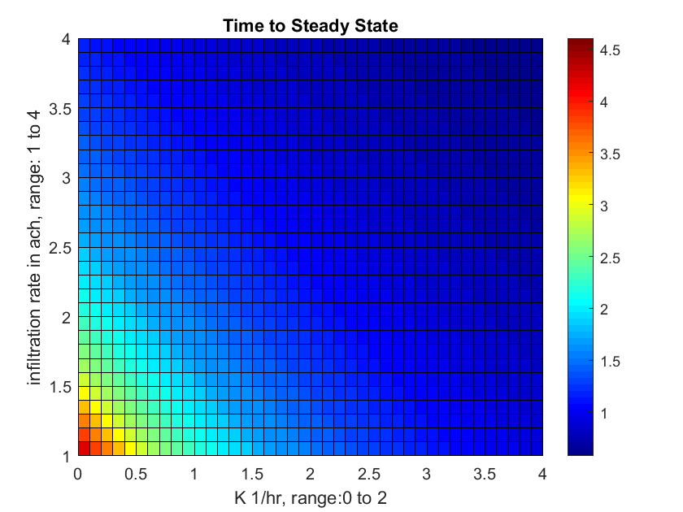

Figure 1. Time to steady state concentration inside a home for particular infiltration and deposition rates.

From previous real-world experimentation we know that a highly conservative estimate of the deposition rate with an in-home HEPA filter is 2. Figure 1 shows that for a deposition rates above around 1.5, infiltration rates are rendered useless. The effect is dominated by deposition. Additionally, we are largely concerned with the effect of pollution from aircraft, which creates plumes of high concentration pollution for short periods of time, on the order of a few minutes. This graphs shows that the time to reach equilibrium is on a much longer timescale. In essence, infiltration rate does not appear to be significant because the timescale it adjusts, even at extremely low deposition rates, is on the scale of hours.

Somewhat deceptively, Figure 1 shows that a higher k leads to a shorter time to reach equilibrium. This is because the equilibrium concentration ratio (indoor versus outdoor) is considerably lower at high Ks as shown in Figure 2. It takes less time to reach a lower concentration.

Figure 2 shows the indoor to outdoor concentration ratio at steady state for particular deposition and infiltration rates. Effectively, this demonstrates the expected efficacy of our solutions. Again, this graphs shows the low impact of infiltration rate compared to deposition rate.

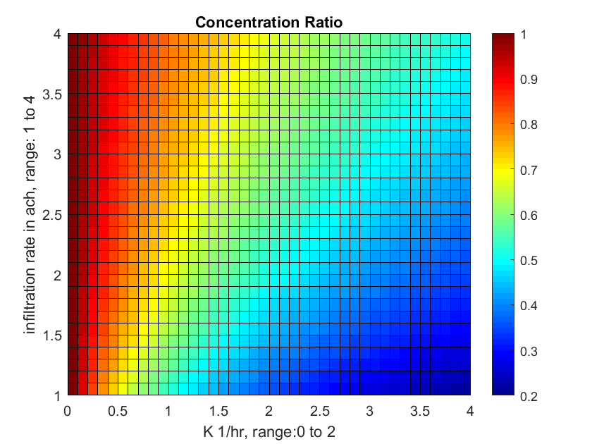

Figure 2. The indoor to outdoor concentration ratio for particular deposition and infiltration rates

From a recent technical assumption test we showed that addressing leaks in windows and doors can reduce the infiltration rate by 28% in a house with particularly bad windows. Assuming the starting I was 3.5, the ending I would be 2.5. For any K, this implies a change in the concentration ratio of about 0.05. That is a questionable affect for the amount of time and effort it takes to install and test infiltration solutions.

Finally, Figure 3 shows the deposition rate required to reach a particular concentration rate for a particular infiltration rate. This graph displays a greater importance of infiltration rate than the previous graphs. We aim to have to greatest impact on air quality as possible, essentially the lowest concentration ration. A ratio of 0.4 would be an impressive result, and we can see that to reach that, the K value would have to be extremely high. We expect that a maximum K would sit around 4 or 5, hence it would be improbable that we reach a low concentration rate without addressing particularly high infiltration rates in-home. 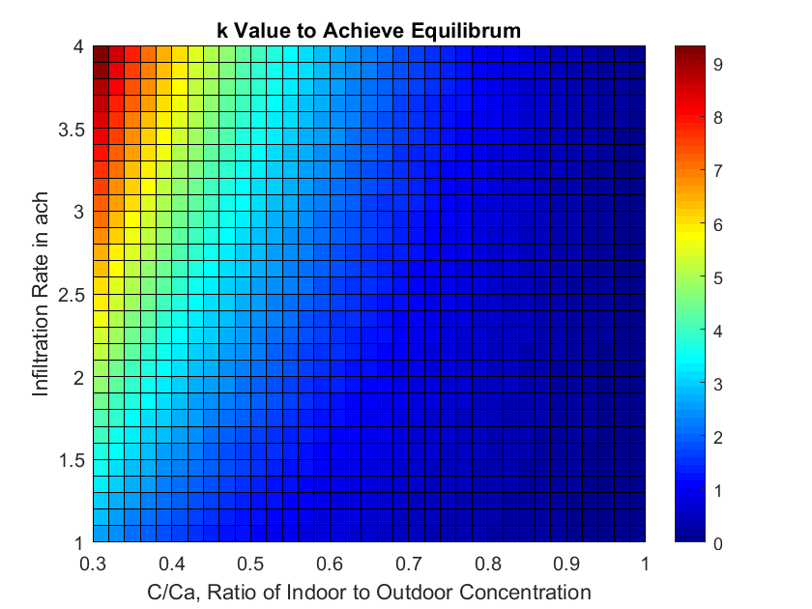

Figure 3. The deposition rate required to achieve a particular indoor to outdoor concentration ratio for a specific infiltration rate.

**Conclusions**

In summary, we built a mathematical model that has given key insights into the expected effects of addressing infiltration rates and deposition rates. Infiltration is inarguably less significant than deposition to impact indoor air quality according to this model. However, at high infiltration rates, which we expect to see in homes with older windows and doors, it might prove to be necessary to address that issue. In the future we must investigate the pros and cons of addressing infiltration rates both on the air quality and business sides.

Appendix A – Matlab model

1. The full Matlab files can be found [in this google dive](https://drive.google.com/drive/folders/1yALtEplgJPine51__0-1IAqG9Lywx_GX?usp=sharing).

<https://drive.google.com/drive/folders/1yALtEplgJPine51__0-1IAqG9Lywx_GX?usp=sharing>